COMMON COURSE ASSIGNMENT FORMAT

Assignment Information

Particular | Details
Department: | COMPUTER SCIENCE AND ENGINEERING
NAME,REG .NO,Programme: | S.PRATEEKSHA-192572137 B.E CSE-AI
Course Code & Course Name | CSA0610-DESIGN AND ANALYSIS OF ALGORITHM
Academic Year / Batch | 2025-2029
Faculty Name | Dr.M.MANIKANDAN
Assignment Title | Student Records Sorting Using Insertion Sort
Date of Issue | 01/09/2026
Date of Submission | 02/09/2026
Maximum Marks | 100
Course Outcome(s) – CO | CO1,CO2.
Bloom's Taxonomy Level | L3 – Apply, L4 – Analyze,
SDG Mapping (SDG 1-17) | SDG 4 – Quality Education
Industry / Societal Relevance | Efficient organization and processing of student academic records

PROBLEM STATEMENT
A university needs to maintain student records according to their CGPA. Develop a program usingInsertion Sort to arrange student records in ascending order of CGPA.
The implementation must:
- Accept student records as input.
- Store the student ID, name, and CGPA.
- Sort records according to CGPA.
- Handle decimal CGPA values.
- Support duplicate CGPA values.
- Implement sorting manually without using built-in sorting functions.
- Test the algorithm with sorted, reverse-sorted, and randomly ordered datasets.
- Compare the performance of the algorithm for different input arrangements.

D. REQUIREMENTS AND CONSTRAINTS
Functional Requirements
- Read the number of students.
- Accept student details.
- Store CGPA values as decimal numbers.
- Sort students in ascending CGPA order.
- Display the sorted student records.
- Measure algorithm performance.
- Test multiple input arrangements.
Constraints

E. STUDENT WORK
1. Problem Understanding and Formulation
Problem
The problem is to organize student records based on their CGPA using the Insertion Sort algorithm.
Input
Each student record contains:
- Student ID
- Student Name
- CGPA
Output
The program produces student records arranged in ascending order of CGPA.
Assumptions
- CGPA values are valid numbers between 0 and 10.
- Student IDs are unique.
- Student names are valid strings.
- Duplicate CGPA values may occur.
- The input contains at least one student record.
Expected Outcome
The final output should display all student records in increasing order of CGPA while preserving the complete student information.
2. APPLICATION OF COURSE KNOWLEDGE
Brute Force Approach
A basic approach is to repeatedly compare student CGPAs and determine the appropriate position of each record. This requires a large number of comparisons when the number of records increases.

Insertion Sort Approach
Insertion Sort divides the records into two portions:
- Sorted portion
- Unsorted portion
Starting from the second record, each record is compared with the records before it. Larger CGPA values are shifted one position to the right, and the current record is inserted into its appropriate position.
Insertion Sort Algorithm
InsertionSort(Student[], N)
for i = 1 to N-1
key = Student[i]
j = i - 1
while j >= 0 AND Student[j].CGPA > key.CGPA
Student[j + 1] = Student[j]
j = j - 1
Student[j + 1] = key
end for

3. SOLUTION / METHODOLOGY
Proposed Method
The proposed system uses Insertion Sort for arranging student records.
Methodology Steps
Step 1: Read the number of students.
Step 2: Read Student ID, Name, and CGPA.
Step 3: Select the second record as the first key.
Step 4: Compare the key CGPA with previous records.
Step 5: Shift records with higher CGPA values to the right.
Step 6: Insert the key at the correct position.
Step 7: Repeat the process for all remaining records.
Step 8: Display the sorted records.
Step 9: Calculate comparisons, shifts, and execution time.
Step 10: Repeat the experiment for sorted, reverse-sorted, and random datasets.

4. SYSTEM FLOW
START
↓
Read Number of Students
↓
Read Student ID, Name and CGPA
↓
Select Current Record
↓
Compare CGPA with Previous Records
↓
Is Previous CGPA Greater?
↓
YES ──→ Shift Previous Record
│ ↓
│ Move to Previous Position
│ ↓
└────── Compare Again
↓
NO ─────────→ Insert Current Record
↓
More Records?
↓ ↓
YES NO
↓ ↓
Repeat Display
Sorted Records
↓
Analyze Results
↓

END
6. USE OF MODERN TOOLS
The assignment format requires evidence of appropriate tool usage where applicable.
GOOGLE COLLAB

7. IMPLEMENTATION
Data Structure
A student record can be represented using a structure/class containing:
Student ID
Student Name
CGPA
The records are stored in an array.
Sorting Criterion
The CGPA field is used as the key for comparison.
if Student[j].CGPA > key.CGPA
shift Student[j]
The comparison continues until the correct position for the current record is identified.
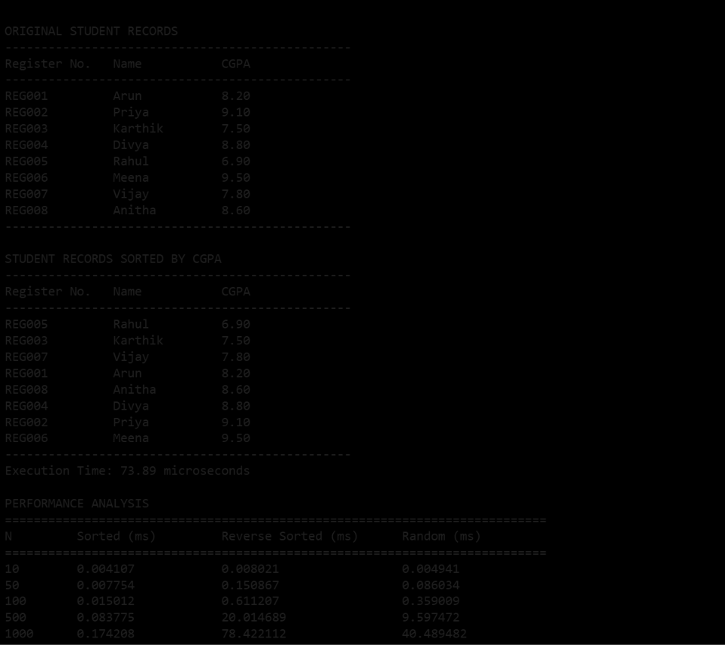

8. TESTING AND VALIDATION
The algorithm should be tested using different input sizes, such as:
- 10 students
- 100 students
- 1,000 students
- 5,000 students
- 10,000 students
- 20,000 students

9. COMPLEXITY ANALYSIS
Explanation
For a sorted dataset, each new record is already in the correct position, so only a small number of comparisons are required.
For a reverse-sorted dataset, every new record must be moved across the previously sorted portion, resulting in the maximum number of comparisons and shifts.
Randomly ordered data generally produces intermediate performance.
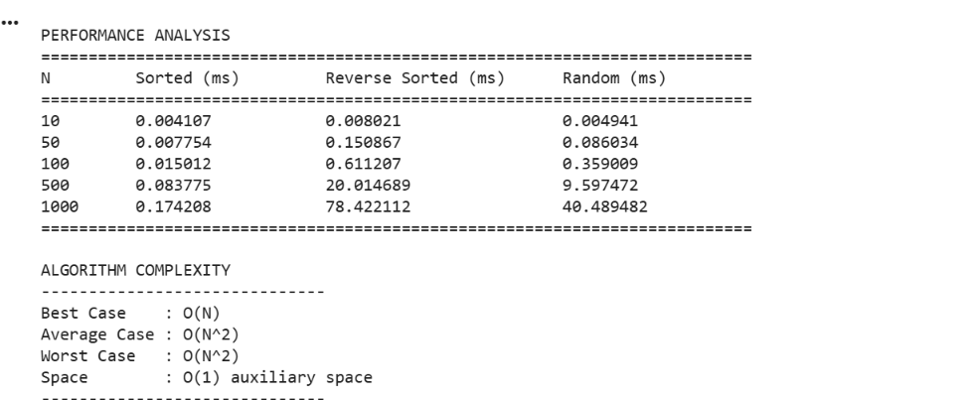

10. RESULTS
The final results should be presented using tables and graphs, as recommended by the Graphs to Include
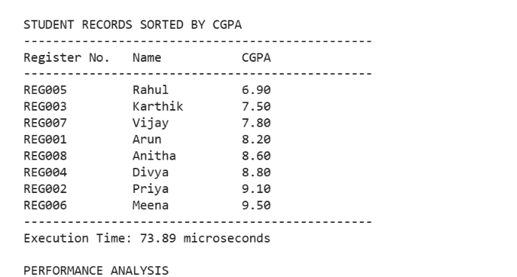
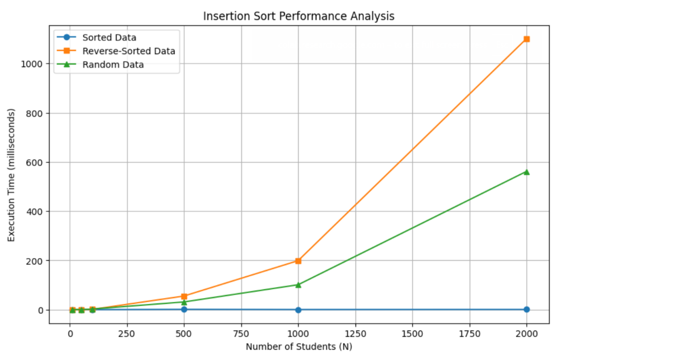
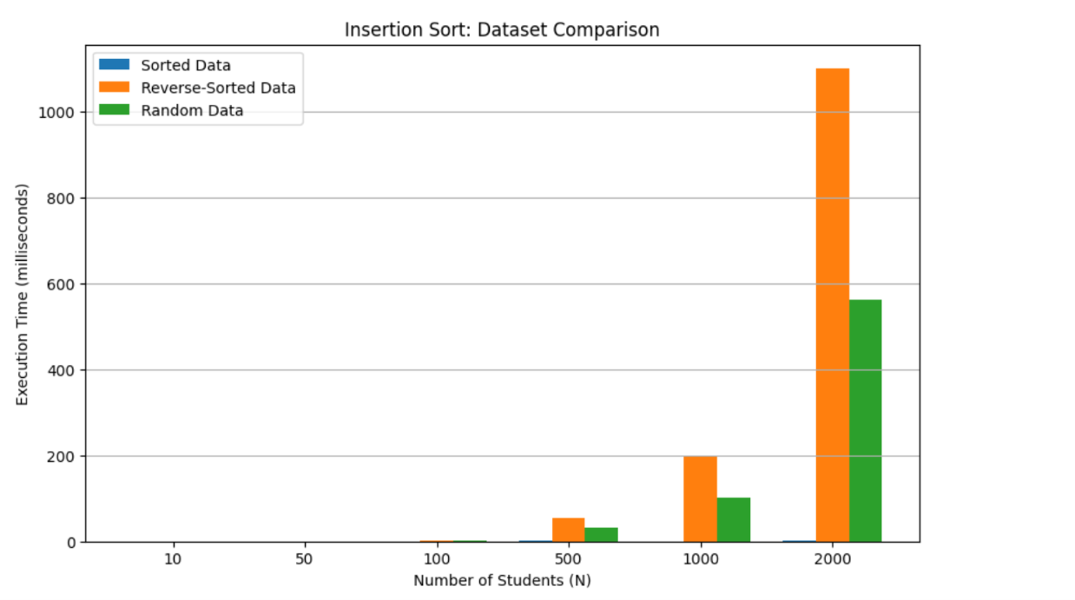

11. ANALYSIS AND ENGINEERING DECISION
The experimental analysis demonstrates that the arrangement of input data has a significant effect on Insertion Sort performance.
The sorted dataset provides the best performance because the records require minimal movement. The reverse-sorted dataset produces the highest number of comparisons and shifts because each record has to be moved across the sorted portion.
The random dataset provides intermediate performance.
Advantages
- Simple to understand and implement.
- Does not require additional array storage.
- Works well for small datasets.
- Efficient when data is already nearly sorted.
- Can handle duplicate CGPA values.
Limitations
- O(N²) average and worst-case time complexity.
- Not suitable for very large unsorted datasets when faster algorithms are available.
- Performance decreases significantly for reverse-sorted data.

12. BROADER CONSIDERATIONS
Sustainability
Insertion Sort requires very little additional memory because it works in-place.
Professional Responsibility
The implementation should correctly preserve the relationship between student IDs, names, and CGPAs while sorting.

Data Privacy
Student academic information is sensitive in real-world systems. Actual student data should be protected and should not be unnecessarily exposed.
Reliability
The algorithm should be tested with decimal CGPAs, duplicate values, minimum/maximum CGPAs, and different input arrangements.

13. CONCLUSION
The Student Records Sorting system successfully applies the Insertion Sort algorithm to arrange student records according to CGPA in ascending order. The algorithm was evaluated using sorted, reverse-sorted, and randomly ordered datasets. The analysis demonstrates that Insertion Sort performs efficiently for already sorted or nearly sorted records, while its performance decreases for reverse-sorted and larger datasets. The experiment also provides practical understanding of algorithm complexity, comparisons, shifting operations, and performance evaluation.
14. STUDENT REFLECTION
This assignment helped in understanding how a sorting algorithm can be applied to a real-world student-record management problem. I learned how Insertion Sort processes records incrementally and how the arrangement of input data affects its performance. The experiment also improved my understanding of time complexity and practical algorithm analysis.
If additional time and resources were available, the implementation could be extended by comparing Insertion Sort with other sorting algorithms such as Merge Sort, Quick Sort, and Heap Sort to determine the most suitable algorithm for larger student datasets.

15. REFERENCES
- Cormen, T. H., Leiserson, C. E., Rivest, R. L., & Stein, C. Introduction to Algorithms. MIT Press.
- Weiss, M. A. Data Structures and Algorithm Analysis. Pearson.
- Goodrich, M. T., Tamassia, R., & Goldwasser, M. H. Data Structures and Algorithms in Python. Wiley.
- Course lecture notes and laboratory materials on Data Structures and Sorting Algorithms.
- Official documentation of the programming language/compiler used for implementation

